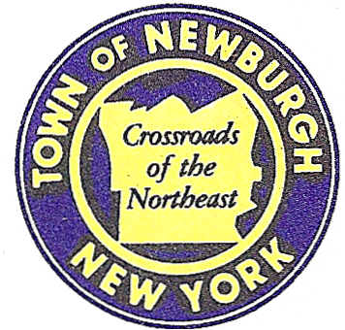

TOWN OF NEWBURGH
_______Crossroads of the Northeast __________________________
OLD TOWN HALL
308 GARDNERTOWN ROAD NEWBURGH, NEW YORK 12550

PLANNING BOARD
JOHN P. EWASUTYN, CHAIRMAN
TELEPHONE 845-564-7804
FAX 845-564-7802
E-MAIL: planningboard@townofnewburgh.org

PLANNING BOARD AGENDA

MARCH 3, 2016

*PLEASE NOTE: The Planning Board Meeting will start at 7:00 P.M. and all Applicants/Representatives
are to be present at that time. The Meeting will be held in the Meeting Room of Town Hall,
located at 1496 Route 300, Newburgh NY.*

- Restaurant Depot (2015-33) SITE PLAN
NYS Route 300
Section 95, Block. 1, Lot 8
Zone: IB
Rep: Larry Marshall, P.E.
Mercurio Norton Tarolli & Marshall
45 Main Street
Pine Bush, NY 12566

2. Gardnertown Commons Amended Site Plan (2016-03) AMENDED SITE PLAN
Gardnertown Road
Section 75, Block 1, Lot 21
Zone: R-3
Rep: JCM Planning Engineering Landscape
120 Bedford Road
Armonk, NY 10504

3. Gardner Ridge ( 2002-29) SITE PLAN
Gardnertown Road near Gidney Avenue
Section 75, Block 1, Lot 4.12
Zone: R-3
Rep: Darren Doce, P.E.
Doce Associates
5020 Route 9W, #19
Newburgh, NY 12550

PLANNING BOARD BUSINESS
WORK SESSION

MARCH 3, 2016
5:30 P.M.

- Lands of Zazon (2004-29): 6 month Extension 3/19/16 – 9/2016

